LEICESTERSHIRE SECONDARY EDUCATION AND INCLUSION PARTNERSHIPS’ AP TOOL KIT
Our Tool Kit is designed to support Alternative Providers (APs) to develop their effectiveness.
Each section contains:
- Key principles that schools and partnerships are concerned to emphasise.
- An audit tool to help APs consider current practice.
- A set of prompts that aim to help providers write a formal policy for the area of work.
- Check lists and tools to assit APs work in this area
- Links to further information.
The great variety in size, focus and scope of individual Alternative Providers means that the way you approach each issue will be unique. LEBC audits and school, partnership and local authority quality assurance checks on APs value the diversity of provision. There is no expectation that you formally use the tool kit, have a standard policy document nor share any self-audit with others. We hope that it will enable you to strengthen your practice and allow you, when asked, to present evidence of self-evaluation.

SUPPORTING ALTERNATIVE PROVIDERS

SPECIAL EDUCATIONAL NEEDS AND DISABILITIES (SEND) POLICIES

- Key Principles that should underpin Alternative Provision SEND Policies
School aged children and young people are placed in Alternative Provision “in order to improve behaviour”. Staff who work with this group of vulnerable young people understand that “behaviour communicates underlying need”. This means that:
- APs should always consider the underlying reasons for a pupil failing to behave well and / or make progress in their learning. Progress is resumed and behaviour is improved when the underlying reason is addressed. Therefore, those working with these young people need to understand the nature of an any additional needs they have and make reasonable adjustments to address those needs.
- APs are not schools and do not have the responsibility of providing a “universal offer”. AP’s SEND policy and practice does not need to be as widely drawn as is in schools. APs have been set up with the aim of meeting some of the needs of these pupils. A starting point for every AP in developing effective SEND practice is to be absolutely clear about the type of need that the offer is intended to meet.
- Audit Tool
Does your policy and practice meet these core principles effectively? This “Self-Audit Document” is designed to allow you to consider whether your policy and practice is as effective as you need it to be.
Audit Statement | RED | AMBER | GREEN | Thoughts / Comments
The AP has a clear offer – including some documentation - that sets out the type of additional needs it aims to address.
Staff are clear about the offer and have a shared understanding of what this means for the way pupils are supported.
The AP has a mechanism appropriate to its size and scope to ensure that it keeps up to date with developing good practice in relation to SEND issues.
The AP has a programme of staff development designed to ensure that staff strengthen their SEND practice.
The AP has a range of tools, checklists etc to help staff think systematically about the nature of a student’s additional needs and how to meet them and these are used regularly
Induction ensures that staff are clear about each pupil’s SEND.
Any targets that have been set by the commissioner for the pupil that are related to addressing SEND needs at the AP are bult into the pupil’s learning plan.
The AP considers carefully any additional reasonable adjustments that need to be made to the pupil’s provision in order to support the pupil and work towards SEND targets, taking advice from the commissioner.
Staff have a confident understanding of the nature of the pupil’s SEN and knowledge of approaches that are effective.
Staff have expertise - within the area of work that they are delivering to pupils - in the sort of difficulties these pupils might encounter as a result of their SEND needs. Staff have a range of strategies that they can use to support pupils through these difficulties.
The AP has an effective process for reviewing general progress and progress towards SEND targets. It reports this as required to the commissioner.
Staff use their knowledge of the pupil’s SEND needs when considering how to respond to a pupil who may be struggling with behaviour, engagement, or learning.
Staff use their wider knowledge in considering whether the pupil has other additional SEND needs that have not been identified.
The AP has a process for evaluating those concerns and reporting them back to the commissioner
The AP ensures that no pupil is prevented from taking part in any planned activity, including visits outside the AP as a result of any SEND. The steps it takes to ensure this are documented and available for scrutiny.
The AP ensures that the pupil has a voice in the planning and evaluation of his or her provision at the AP, especially concerning any reasonable adjustments made to assist the pupil.
Someone at the AP has a good understanding of EHCPs and associated reviews and guide staff in responding to any requirements arising form the EHCP
The AP is self-reflective and committed to continuous improvement in respect of SEND.

- What might be in an AP SEND Policy

- A description of your offer
  - What are the core learning activities that you offer?
  - What are the needs that you are aiming to address?
- Statement of your understanding of SEND and why it is important at your provision
- How do you make sure that you recognise the SEND needs of each young person?
  - The information you make sure you get from the commissioner of the provision, including documentation such as EHCPs.
  - The way that you and your staff keep an eye out for further evidence of SEND that may emerge in your setting. This will include
    - Careful analysis of any new negative behaviours that the young person exhibits
    - The tracking of progress, and identification of any particular learning issues that the young person has difficulty with
    - Any checklist or diagnostic tools that you use to help you with I and ii.
- How do ensure that the teaching and learning in the provision takes account of the SEND of learners?
  - What measures do you build into your provision as part of your normal arrangements to take account of the likely SEND needs of learners?
  - In particular and in the light of the fact that most learners will have semh issues, what are the in built measures that address the issues that are likely to arise?
  - How might you adjust provision in the light of particular SEND?
- What are you arrangements for
  - reporting to commissioners on progress of learners
  - Raising with or feeding back to commissioners any concerns you have about SEND issues for individual learners.
  - Providing more detailed information for SEND Learners with EHCPs where you may be asked to contribute to statutory reviews
- Who is responsible for leading on the issue of SEND.
  - How do they keep up to date with SEND developments
  - Any outside sources of support with SEND issues that the SEND leader uses
- A description of the arrangements you make to ensure that staff receive up tp date training aligned to the SEND issues they are likely to encounter at the provision.

- CHECKLIST FOR AP’s FOR USE WHEN THINKING ABOUT A LEARNER’S SEND
Are we doing what we should to support the learner?
Do we know enough about the learner’s needs?
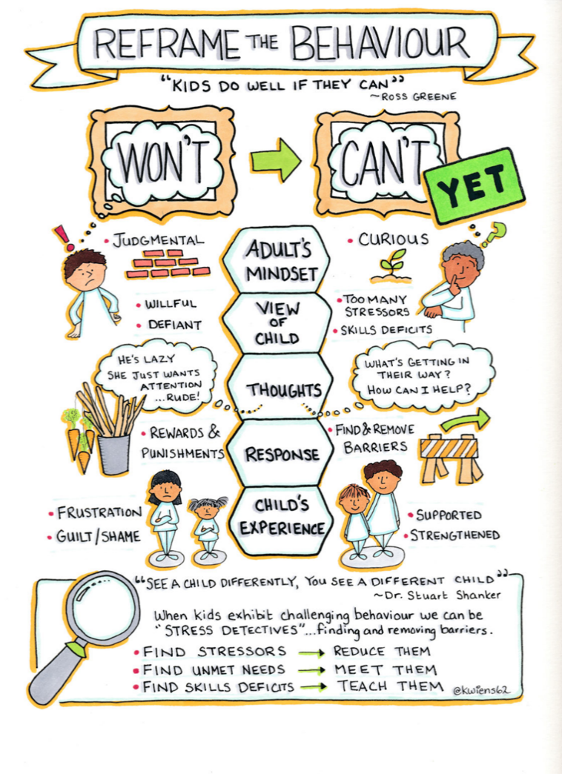

What are these checklists for?
- For individuals or groups of staff to think further about an individual learner’s needs
- For individuals or groups of staff to think about how to respond to those needs
- To use as part of a report back to the learner’s commissioner to deepen understanding of the learner’s needs and how they should be met.
- To prepare contributions to reviews that might be requested by the commissioner, particularly for learners with EHCP’s
How to use the checklists
The four areas of SEND are
- Cognition and learning.
- Communicating and interacting. ...
- Social, emotional and mental health difficulties. ...
- Sensory and/or physical needs.

The check lists cover these four areas as you are likely to encounter them in your provision. A check list drawn from the Autism Pathway is included – Autism Spectrum disorder is seen by the SEN Code of Practice as set of needs under the heading of Communicating and interacting.
Tick or highlight as appropriate to indicate what has been tried or observed
Cognition and Learning: eg slow rate of progress, slow processing
Curriculum Content:
- The curriculum is individually differentiated in some areas to meet need
- Teaching plans include how child/young person’s needs are being addressed and how progress will be monitored.
- Individual learning outcomes in some areas.
- Adequate intellectual challenge and stimulation in all lessons (this is particularly relevant for children/young people with higher cognitive skills and lower literacy skills)
Curriculum Delivery:
- Pre-tutoring of useful vocabulary and key concepts.
- Regular reinforcement of instructions.
- Personalised feedback given on learning – both teacher led or peer-led.
- Flexibility within the timetable to allow for interventions to be implemented
- Assisted technology.
Classroom resources:
- Teaching assistants used to complement the teacher's planning and delivery, the teacher remains accountable for the child/young person’s learning at all times
- Resources to assist with accessing the content of the lesson such as Reading pens or a reader.
- Resources to assist with recording work such as a scribe, IT, dictaphone, talking tins.
Staff Knowledge and Understanding:
- Teachers are regularly involved with intervention planning with the SENDCo and time is put aside for this.
- Teachers are offered relevant training sessions to increase skills and knowledge to support interventions.
Communication and Interaction eg difficulty sharing what is wrong, aggression, frustration, difficulty following verbal instructions, poor social communication with peers, friendship problems
I CAN Checklist:
What to expect between the ages of 11 and 14
At this stage children will: | Problem with this?
Use longer sentences; usually 7-12 words or more
Build their sentences using a range of conjunctions or joining words, such as 'meanwhile', 'however', 'except' so that they can convey complex ideas
Know how to use sarcasm. Know when others are being sarcastic to them
Be able to change topic well in conversations
Use more subtle and witty humour
Show some understanding of idioms, such as “put your money where your mouth is!”
Know that they talk differently to friends than to teachers and be able to adjust this easily
Understand and use slang terms with friends. They keep up with rapidly changing ‘street talk’.
What to expect between 14-17 years
As they get older, young people can:
Follow complicated instructions
Know when they haven’t understood. They will ask to be told again or have something specific explained
Easily swap between ‘classroom’ talk and ‘break-time’ talk
Tell long and very complicated stories.
Things to Look Out For
At this stage, children should have well-developed speech, language and communication skills. At this age, a child might have delayed language if they: | Seen?
Have difficulty giving specific answers or explanations
Have difficulty sequencing their ideas in the right order
Are better at understanding individual instructions than group instructions
Find it difficult to understand language where the meaning isn’t clearly stated e.g. be able to infer that someone wants to close the window or turn up the heating when they say ‘It’s a bit chilly in here!’
Find long and complicated instructions hard to understand
Have trouble learning new words
Take a long time to organise what they are going to say or write
Take things too literally. For example, “I’ll be back in a minute”
Have difficulty taking turns in conversations
Talk to teachers and friends in the same way.

Social Emotional Mental Health eg self-regulation problems, engagement problems, mood swings
Strategies in use (highlight):
- Additional contact and interaction with adults, e.g. meet and greet and regular checking-in times
- Additional verbal and visual prompts
- Additional reinforcement and praise for desired behaviour, including any structured reward systems that are developed with the child/young person
- Additional structured activities at unstructured times, e.g. at playtime and lunchtime if this is when there are concerns
- Mentoring
- Daily home-school communication and support for the family, if required
- Small group social skills work
- Lunchtime clubs
- The use of visual structures to support classroom routines,eg visual timetable and other symbols/photos, choice boards, ‘Now/Then’ cards
- Activity boxes
- Emotion coaching scripts
The use of strategies to support concentration, such as:
- wobble cushions
- weighted cushions
- egg timers
- low arousal table
- movement breaks
Sensory Needs eg over or under stimulation, sensation seeking in the classroom, sensory processing disorder
- Being sensitive to sensory information (over-responding or hyper-responsive)
- Being slow to notice or being oblivious to sensory information (under-responding or hypo-response)
- Looking for more sensory information (sensory seeking or craving)
- Finding it difficult to plan and organise their movement (dyspraxia)
- Having poor balance and being clumsy (poor postural control)
- Having poor awareness of the qualities of sensory information (discrimination)

Autism pathway diagnostic criteria observed in setting (highlight):
Social interaction and reciprocal communication behaviours
Spoken language
- Spoken language may be unusual in several ways:
  - very limited use
  - monotonous tone
  - repetitive speech, frequent use of stereotyped (learnt) phrases, content dominated by excessive information on topics of own interest
  - talking 'at' others rather than sharing a two-way conversation
  - responses to others can seem rude or inappropriate.
Interacting with others
- Reduced or absent awareness of personal space, or unusually intolerant of people entering their personal space.
- Long-standing difficulties in reciprocal social communication and interaction: few close friends or reciprocal relationships.
- Reduced or absent understanding of friendship; often an unsuccessful desire to have friends (although may find it easier with adults or younger children).
- Social isolation and apparent preference for aloneness.
- Reduced or absent greeting and farewell behaviours.
- Lack of awareness and understanding of socially expected behaviour.
- Problems losing at games, turn-taking and understanding 'changing the rules'.
- May appear unaware or uninterested in what other young people his or her age are interested in.
- Unable to adapt style of communication to social situations, for example, may be overly formal or inappropriately familiar.
- Subtle difficulties in understanding other's intentions; may take things literally and misunderstand sarcasm or metaphor.
- Makes comments without awareness of social niceties or hierarchies.
- Unusually negative response to the requests of others (demand avoidant behaviour).
Eye contact, pointing and other gestures
- Poorly integrated gestures, facial expressions, body orientation, eye contact (looking at people's eyes when speaking) assuming adequate vision, and spoken language used in social communication.
Ideas and imagination
- History of a lack of flexible social imaginative play and creativity, although scenes seen on visual media (for example, television) may be re-enacted.
Unusual or restricted interests and/or rigid and repetitive behaviours
- Repetitive 'stereotypical' movements such as hand flapping, body rocking while standing, spinning, finger flicking.
- Preference for highly specific interests or hobbies.
- A strong adherence to rules or fairness that leads to argument.
- Highly repetitive behaviours or rituals that negatively affect the young person's daily activities.
- Excessive emotional distress at what seems trivial to others, for example change in routine.
- Dislike of change, which often leads to anxiety or other forms of distress including aggression.
- Over or under reaction to sensory stimuli, for example textures, sounds, smells.
- Excessive reaction to taste, smell, texture or appearance of food and/or extreme food fads.
Other factors that may support a concern about autism
- Unusual profile of skills and deficits (for example, social or motor coordination skills poorly developed, while particular areas of knowledge, reading or vocabulary skills are advanced for chronological or mental age).
- Social and emotional development more immature than other areas of development, excessive trusting (naivety), lack of common sense, less independent than peers.

5.Links to Further Information

SEND Code of Practice
Leicestershire SEND Support Handbook
Beacon Support SEND Cheat Sheets
NASEN SEND Handbook

